**New Brewery Opening Location**

1. **Introduction**:

As part of the IBM capstone project, I have chosen an idea related to *opening a new Brewery* in a location of my preference i.e. Bangalore.

Bangalore is famous for its pubs, bars and brewery culture. So, this got me interested in finding out what locations/neighborhoods in Bangalore would be

suitable for opening a new brewery or a branch of an existing brewery.

One of the motivations for choosing this problem statement is related to my preference for brewed beer vs bottled beer – I occasionally do enjoy bottled beer,

but given a choice I would choose freshly brewed. Also, in case of brewed beer there are many options in terms flavors and concentrations to choose from.

And I am seeing an increasing trend in this behavior and will result in many new breweries opening with more variations in their menu.

From the business point of view, the location of an outlet can make or break decision. Many factors contribute to the success of running bar, pub or brewery.

Primary being the location/neighborhood, and others include surrounding venues, type of crowd in the neighborhood, main landmarks etc.

So in this project, I will using clustering concept to find the best possible locations in Bangalore to open a Brewery.

1. **Data acquisition:**

For any data science project, the quality of data is more important than the quantity of data. The key data that I will be using in this project is the location data of Bangalore

neighborhood i.e. longitude and latitude of key places. Along with this to fetch venue details of places around these neighborhood , I will be using the Foursquare APIs .

Below is snapshot of the location data of Bangalore neighborhood. It contains neighborhood name, pin code, zone(*east, west etc.*), longitude and latitude.

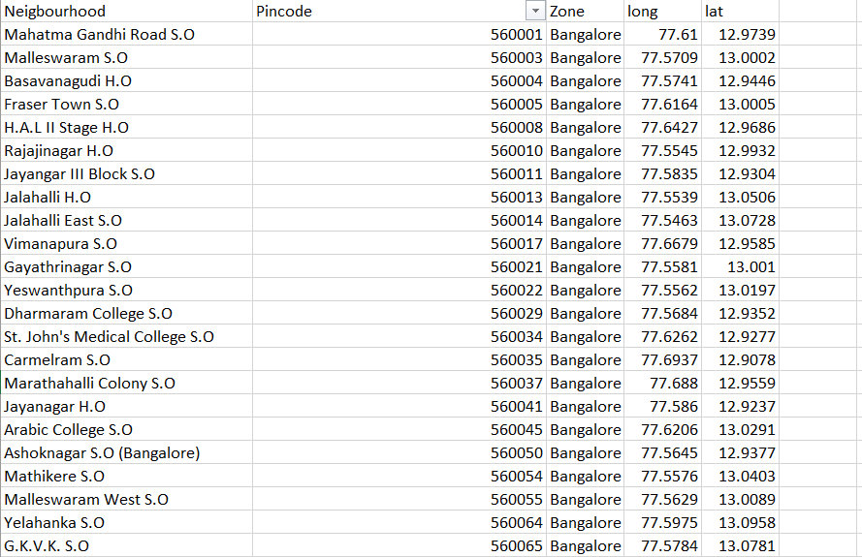

Along with this, I would be using the venues information in and around these neighborhoods. That will look like something like shown below.

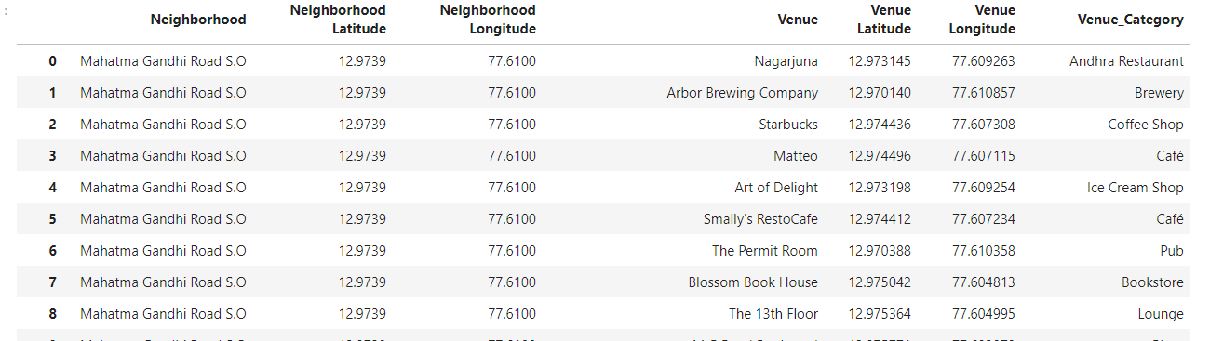

1. **K-means clustering**
2. **Analysis the clusters**
3. **Conclusion**